THERMODYNAMIC CYCLE SIMULATOR

Name: T.Hemanth

ROLL NO:24705A0312

BRANCH:MECHANICAL ENGINEERING

* Simulates cycle like otto,ranline,Brayton
* Input:compression ratio,temperature,pressure
* Output:P-V and T-S diagram,cycle efficiency,workdone
* Libraries:matplotli,coolprop
* CODE
* a=int(input("eneter the value of compression ratio :"))#otto cycle
* efficiency=1-(1/a**0.4)
* print("efficiency of otto cycle:",efficiency*100,"%")
* b=int(input("enter the value of heat in:"))
* workdone=b*efficiency
* print("work done for the otto cycle:",workdone,"kj")
* import numpy as np
* import matplotlib.pyplot as plt
* x=[8,2,2,8,8]
* y=[2,4,8,6,2]
* plt.plot(x,y)
* plt.xlabel("volume(v)")
* plt.ylabel("pressure(p)")
* plt.title("pressure vs volume graph")
* plt.show()

OUTPUT:

eneter the value of compression ratio :8

efficiency of otto cycle: 56.472471835193794 %

enter the value of heat in:933

work done for the otto cycle: 526.8881622223581 kj

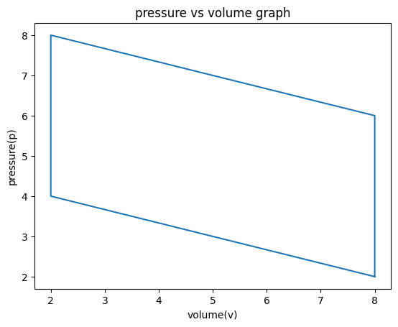

**Conclusion on Otto Cycle**

The Otto cycle is the fundamental idealized thermodynamic cycle that models the operation of spark-ignition internal combustion engines, such as those in most gasoline-powered vehicles. It consists of two isentropic processes and two constant-volume heat transfer processes, representing compression, combustion, expansion, and exhaust phases.